**16 bit multiplication:**

**Code:**

lhld 2001

xchg

lhld 2020

mov c,h

mvi a,00h

loop: add d

dcr c

jnz loop

mov h,a

mov b,l

mvi a,00h

lp: add e

dcr b

jnz lp

mov l,a

shld 2050

hlt

**OUTPUT:**

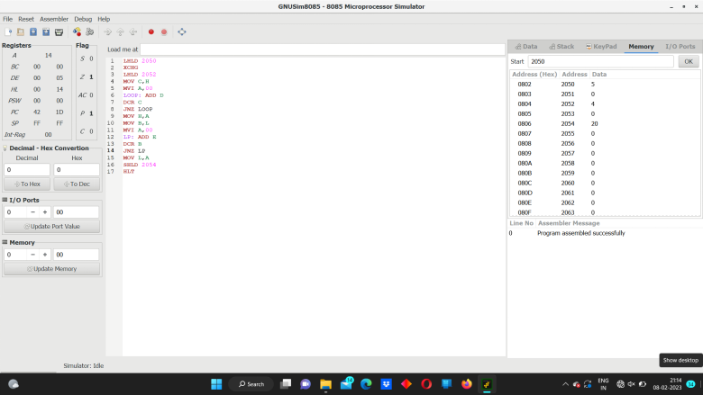**sss**